**Lab Task 3**

**My Application: Multiple Cards**

**Objective:** This lesson we look at cards and how to add a new one to your stack.

## 1. Open you stack / Create a new one

First start by opening your stack or creating a new one

## 2. Open the Project Browser

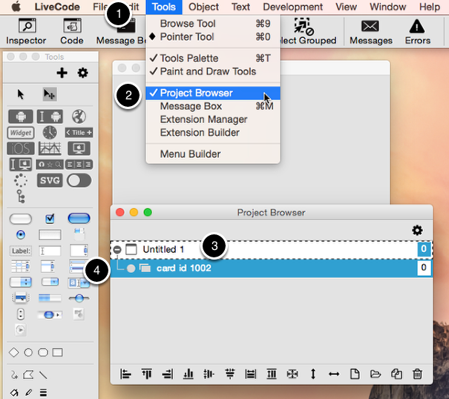

1) Go to the tools menu

2) Select 'Project Browser'

3) You'll see your stack on the list.

4) Expand it to view the list of cards in your stack

## 3. Add a new card

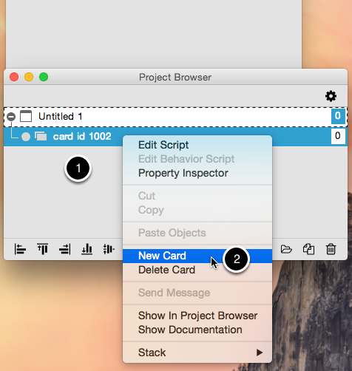

1) Right click on the card you would like the new card to be placed after

2) Select 'New Card'

That's it. You should now have a new card. To view it's properties, rename it, relayer it etc:

1) Right click on the card you would like to alter the properties of

2) Select 'Property Inspector'

## 4. Add 'next' and 'back' button.

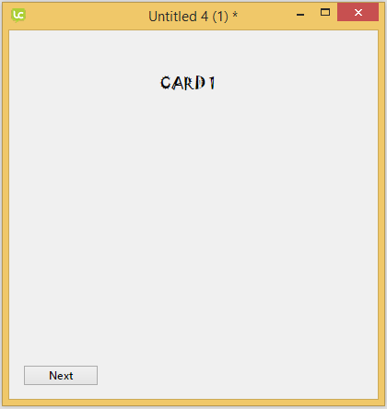 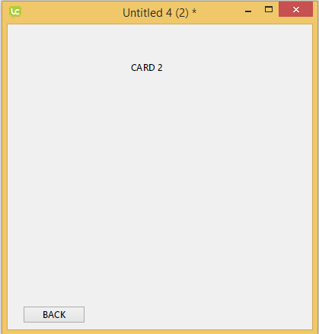

1. Put 'next' button on card 1 and 'back' button on card 2.
2. Put the following code in 'next' button

**on** mouseUp

**go** to **next**

**end** mouseUp

1. Put the following code in 'back' button

**on** mouseUp

**go** to **previous**

**end** mouseUp

**Tutorial Question:**

1. Decorate each card using your own creativity. Put image, text and colour in your card.